**RWBY RPG COMBAT ENGINE**

**Design Document**

**Genre:** Fighting

**Game Modes**: Multiplayer

**Concept:** The concept of this project is to be a demo of a combat engine for a RPG like game. It is to be 1 vs. 1 multiplayer. Larger battles may be a concept for the future but would likely need a significant reworking of the gam eplay mechanics. No AI is currently planned.

**Gameplay:**

**Stats:**

Health: The health of the character. Losing all health is a loss condition. Float displayed as Integer.

Defense: The ability of the character to reduce incoming damage. Percentage.

Melee: The strength of melee attacks of the character. Percentage.

Ranged: The strength of ranged attacks of the character. Percentage.

Spirit: The ability of the character to regenerate their aura. Percentage

Endurance: The amount of aura a character has. Float displayed as Integer.

Dodge: The chance of a character dodging attacks, affected by distance and aura remaining. Percentage.

Speed: Determines attack order, affected by aura remaining. Float.

**Mechanics:**

**Health:** The amount of damage a character can take before they collapse. Defense helps prevent damage to health.

**Aura:** Used for the majority of actions including attacking, moving, and using semblances. Amount of aura is determined by endurance and regeneration amount each turn is determined by spirit. Amount remaining effects Dodge chance, Speed. and Defence.

**Turns:** Every game turn is split into three phases. During the first phase the player can either change stance, defend, use their active semblance, or skip the phase. During phase two the player can either move or skip the phase. During phase three the player may attack and/or defend. In phase three the characters speed determines action order and it is possible to attack an opponent before they fully defend.

**Stance:** The two stances are melee and ranged. The stance affects what attacks can be performed. It also affects the ability to move as well as modifying defense. Ranged gives 80% multiplicative of base defense, Melee has 100% base defense. Switching stance incurs a 50% attack penalty for the rest of the turn. Stance changes happen before movement or attacking,

**Position:** The battlefield is laid out as a 1x8 grid. Characters can move backwards until they hit the edge of the battlefield, and can move forward until stopped by the opponent character. If a character is cornered the arena will “expand” 2 squares. In ranged stance a character can move once a turn, and in melee stance you can move twice with a 10% penalty to aura. Moving once gives a 25% attack penalty, moving twice gives a 50% attack penalty. Penalties last till the end of the turn and are multiplicative of other penalties. ex. 50% from stance change * 25% (75% remaining) from moving = 37.5% of full damage. The distance between opponents also effects dodge chance. If opponents are adjacent the base dodge chance is used. and 2% is added for every further square for attacks in ranged stance, and 3% for every square for off-stance ranged attack,

**Attacking:** Each character has 3 attacks for each stance. In the case of ranged this with be two ranged attacks and one melee. And in melee it will be two melee attacks and one ranged. The two stance attacks are one strong and one weak, and the off-stance move is weak but should typically do more damage than moving or changing stance and then attacking with a proper stance attack with a penalty. Strong attacks have 115 health base damage and take 100 aura, weak attacks have a 75 base damage and take 60 aura, off-stance attacks have a 50 base damage and take 55 aura. Base damage is affected by melee and ranged stats. Attacks do half of their base damage to the targets aura.

**Defending:** If defending is used before moving it will prevent moving and reduce incoming and outgoing damage by 50%. If defending is used after moving it will reduce incoming damage by 25% and outgoing damage by 75%. If a character has been attacked in phase three before defending it will only reduce incoming damage by 15%.

**Semblance:** Every character has a passive semblance and an active semblance. Passive semblances give slight bonuses to characters and active semblances can be used during a turn. Using a semblance requires the entire turn. They typically cost a larger amount of aura that is dependent on the character. Effects vary from character to character and will be explained in the character section.

**Characters:**

**Ruby Rose:**

**Stats:**

Health: 500

Defense: 15%

Melee: 90%

Ranged: 110%

Spirit: 15%

Endurance: 300

Dodge: 9%

Speed: 11

**Attacks:** (Attack Names Temporary)

**Ranged:**

Aimed Shot (Heavy)

Quick Shot (Weak)

Defensive Cut (Melee)

**Melee:**

Heavy Cut (Heavy)

Quick Cut (Weak)

Folded Shot (Ranged)

**Semblance:** Agility

**Passive:** Ruby can move two squares while in ranged stance with a 75% damage penalty.

**Active:** Speed Boost. Allows Ruby to move one space with no damage penalty, two with a 15% penalty, 3 with a 50% penalty, and 4 with a 80% penalty. If the arena needs to be “expanded” to use the 3rd move it can. However, if there is no more room a 4th move cannot be made.

**Yang Xiao Long:**

**Stats:**

Health: 650

Defense: 25%

Melee: 110%

Ranged: 80%

Spirit: 9%

Endurance: 450

Dodge: 4%

Speed: 6

**Attacks:** (Attack Names Temporary)

**Ranged:**

Aimed Slug (Heavy)

Slug Barrage (Weak)

Quick Punch (Melee)

**Melee:**

Shotgun Punch (Heavy)

Quick Punch (Weak)

Shotgun Shot (Ranged)

**Semblance:** Damage Sponge

**Passive:** As her health gets lower her stats go up. They will continue to rise until 15% health is left. Defense can be increased by 10%, Melee and Ranged by 20%, Spirit by 3%, Dodge by 3%, and Speed by 2.

**Active:** Super Saiyang. Can only be activated at under 50% health. Allows Yang to move 3 squares in a turn with no damage penalty as long as there is space. Increases Defense by 10%, Melee and Ranged attack by 15%, Dodge by 5%. amd Speed by 2. Stat increases stack additively with the passive increases. Stat increases are only valid during the turn the Semblance is activated and it disables the passive Semblance for two turns after.

**UI:**

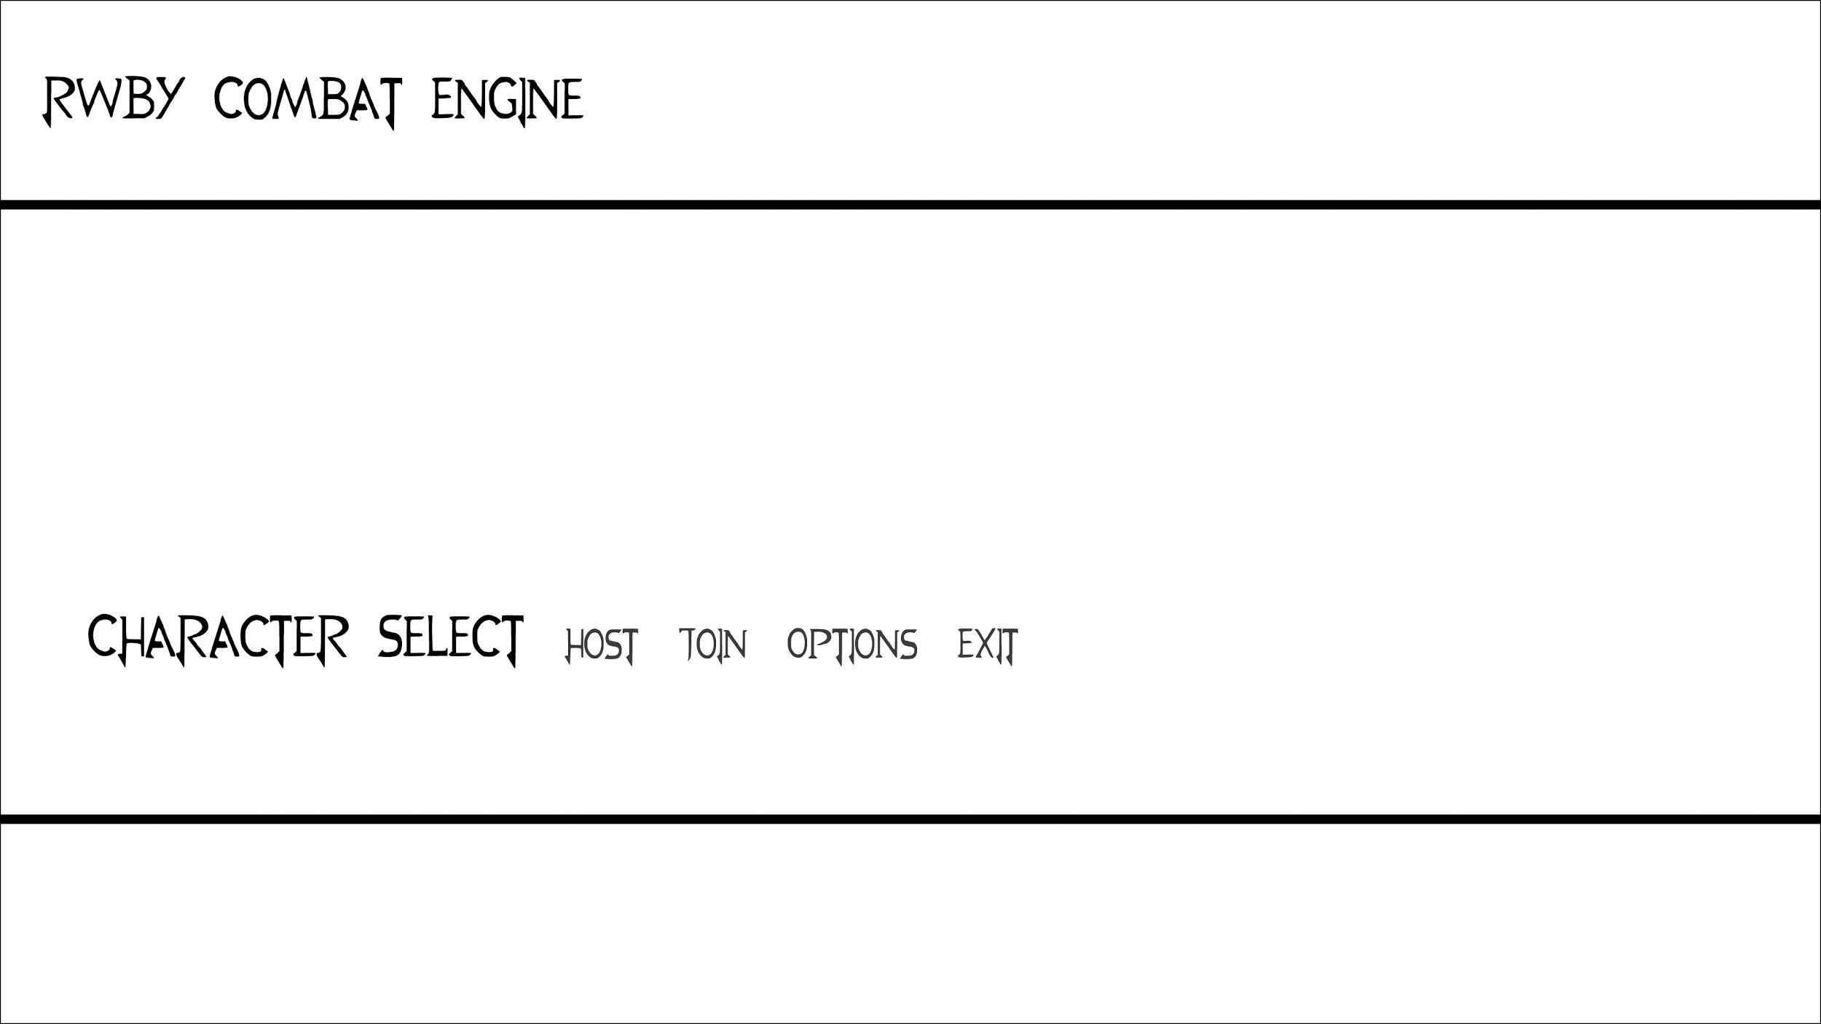

**Main Menu:**

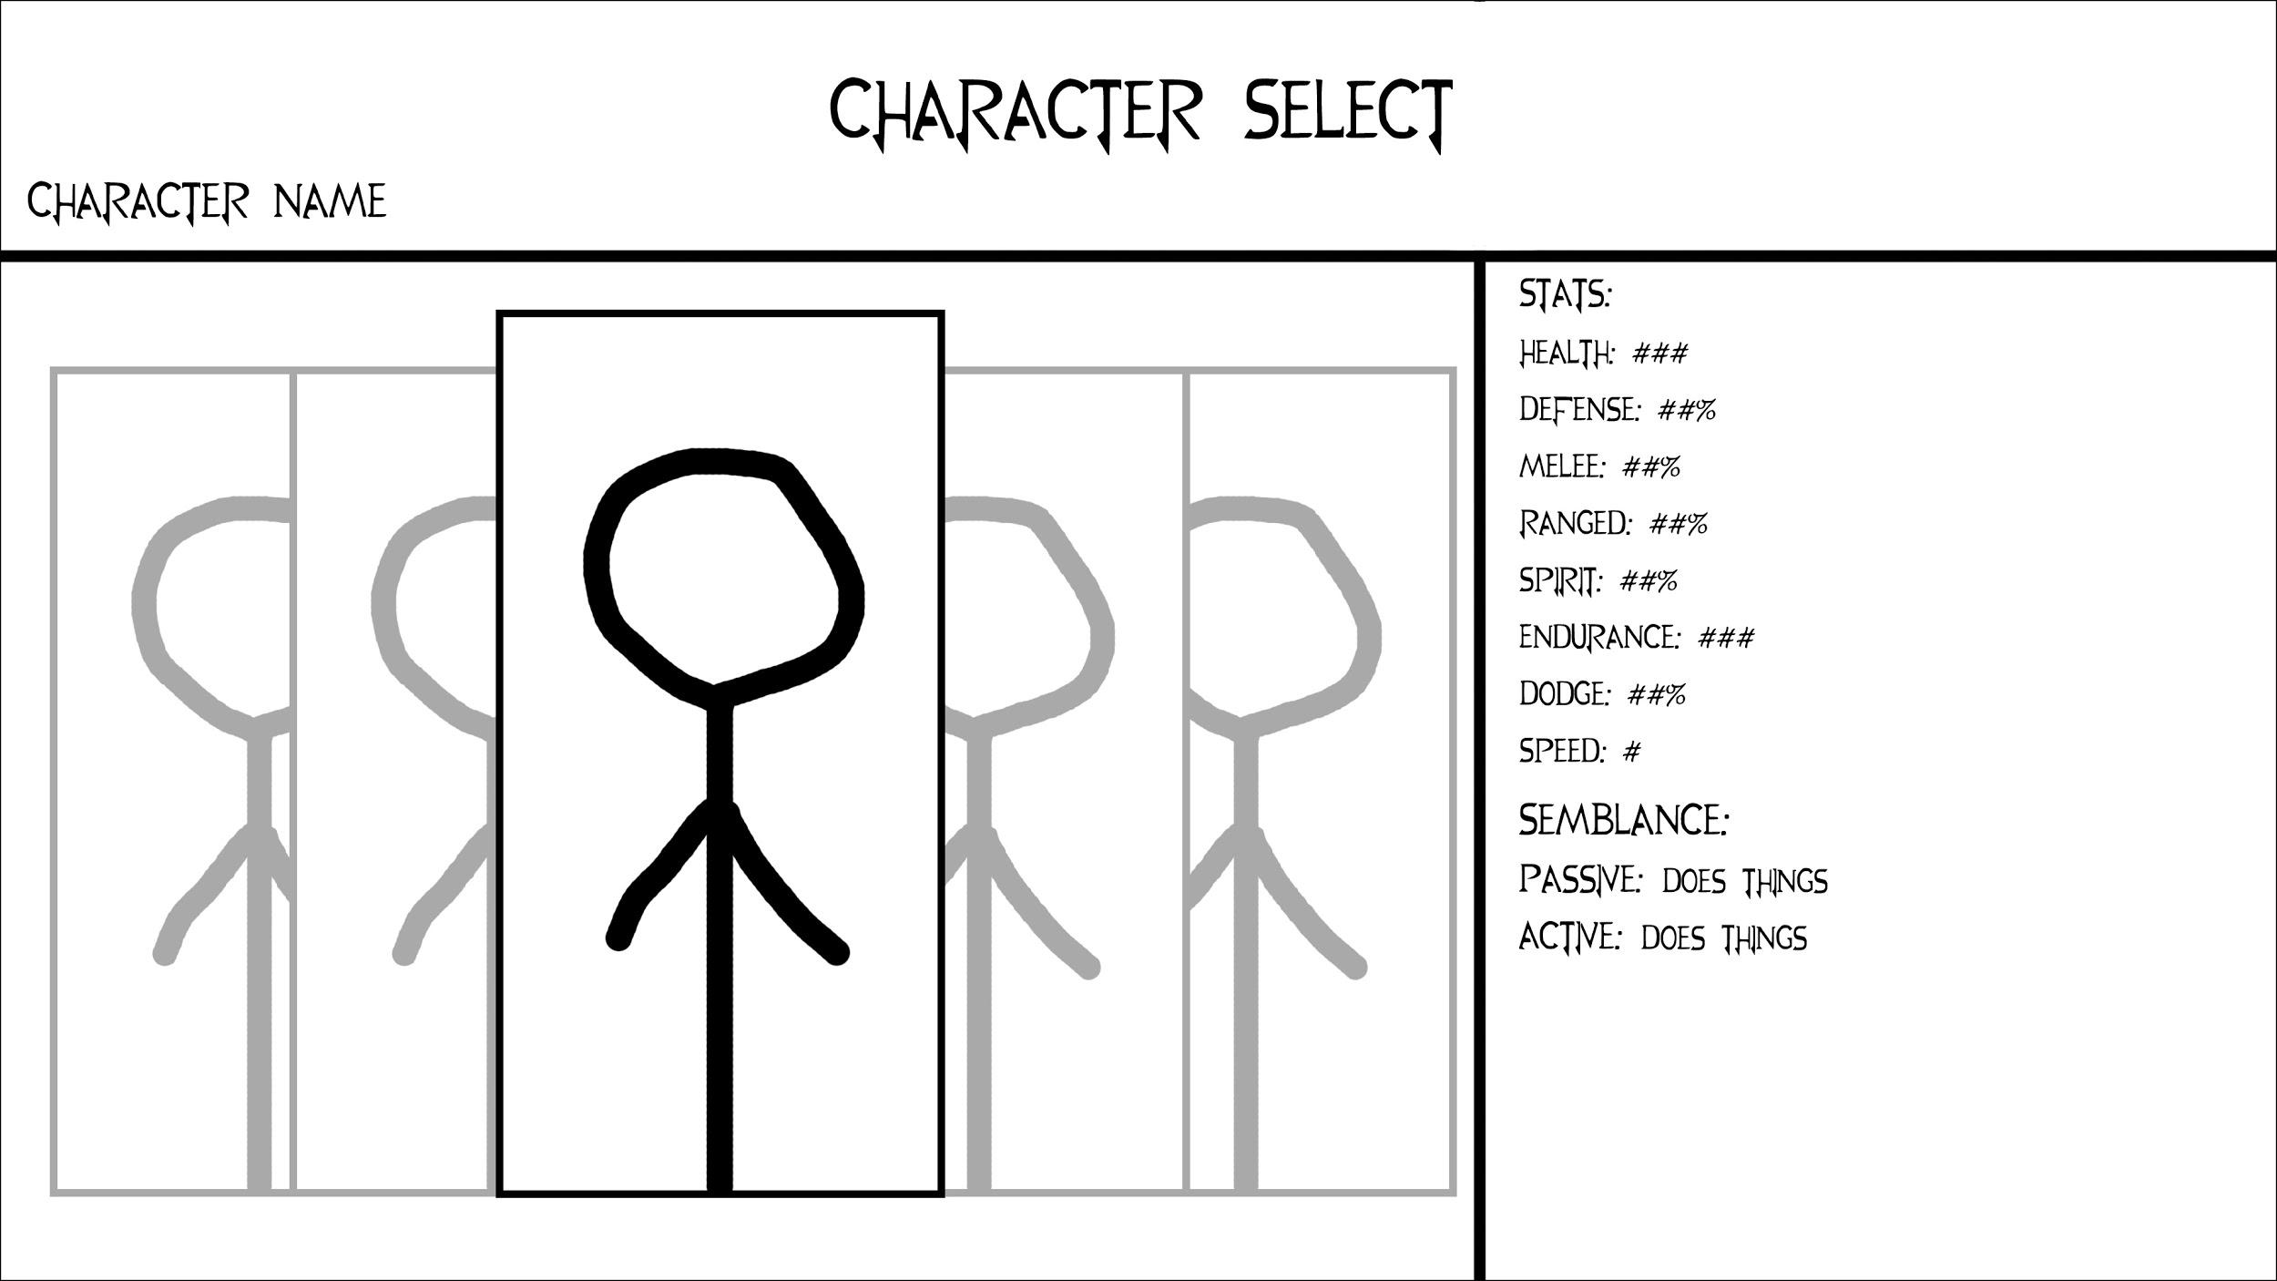

**Character Select:**

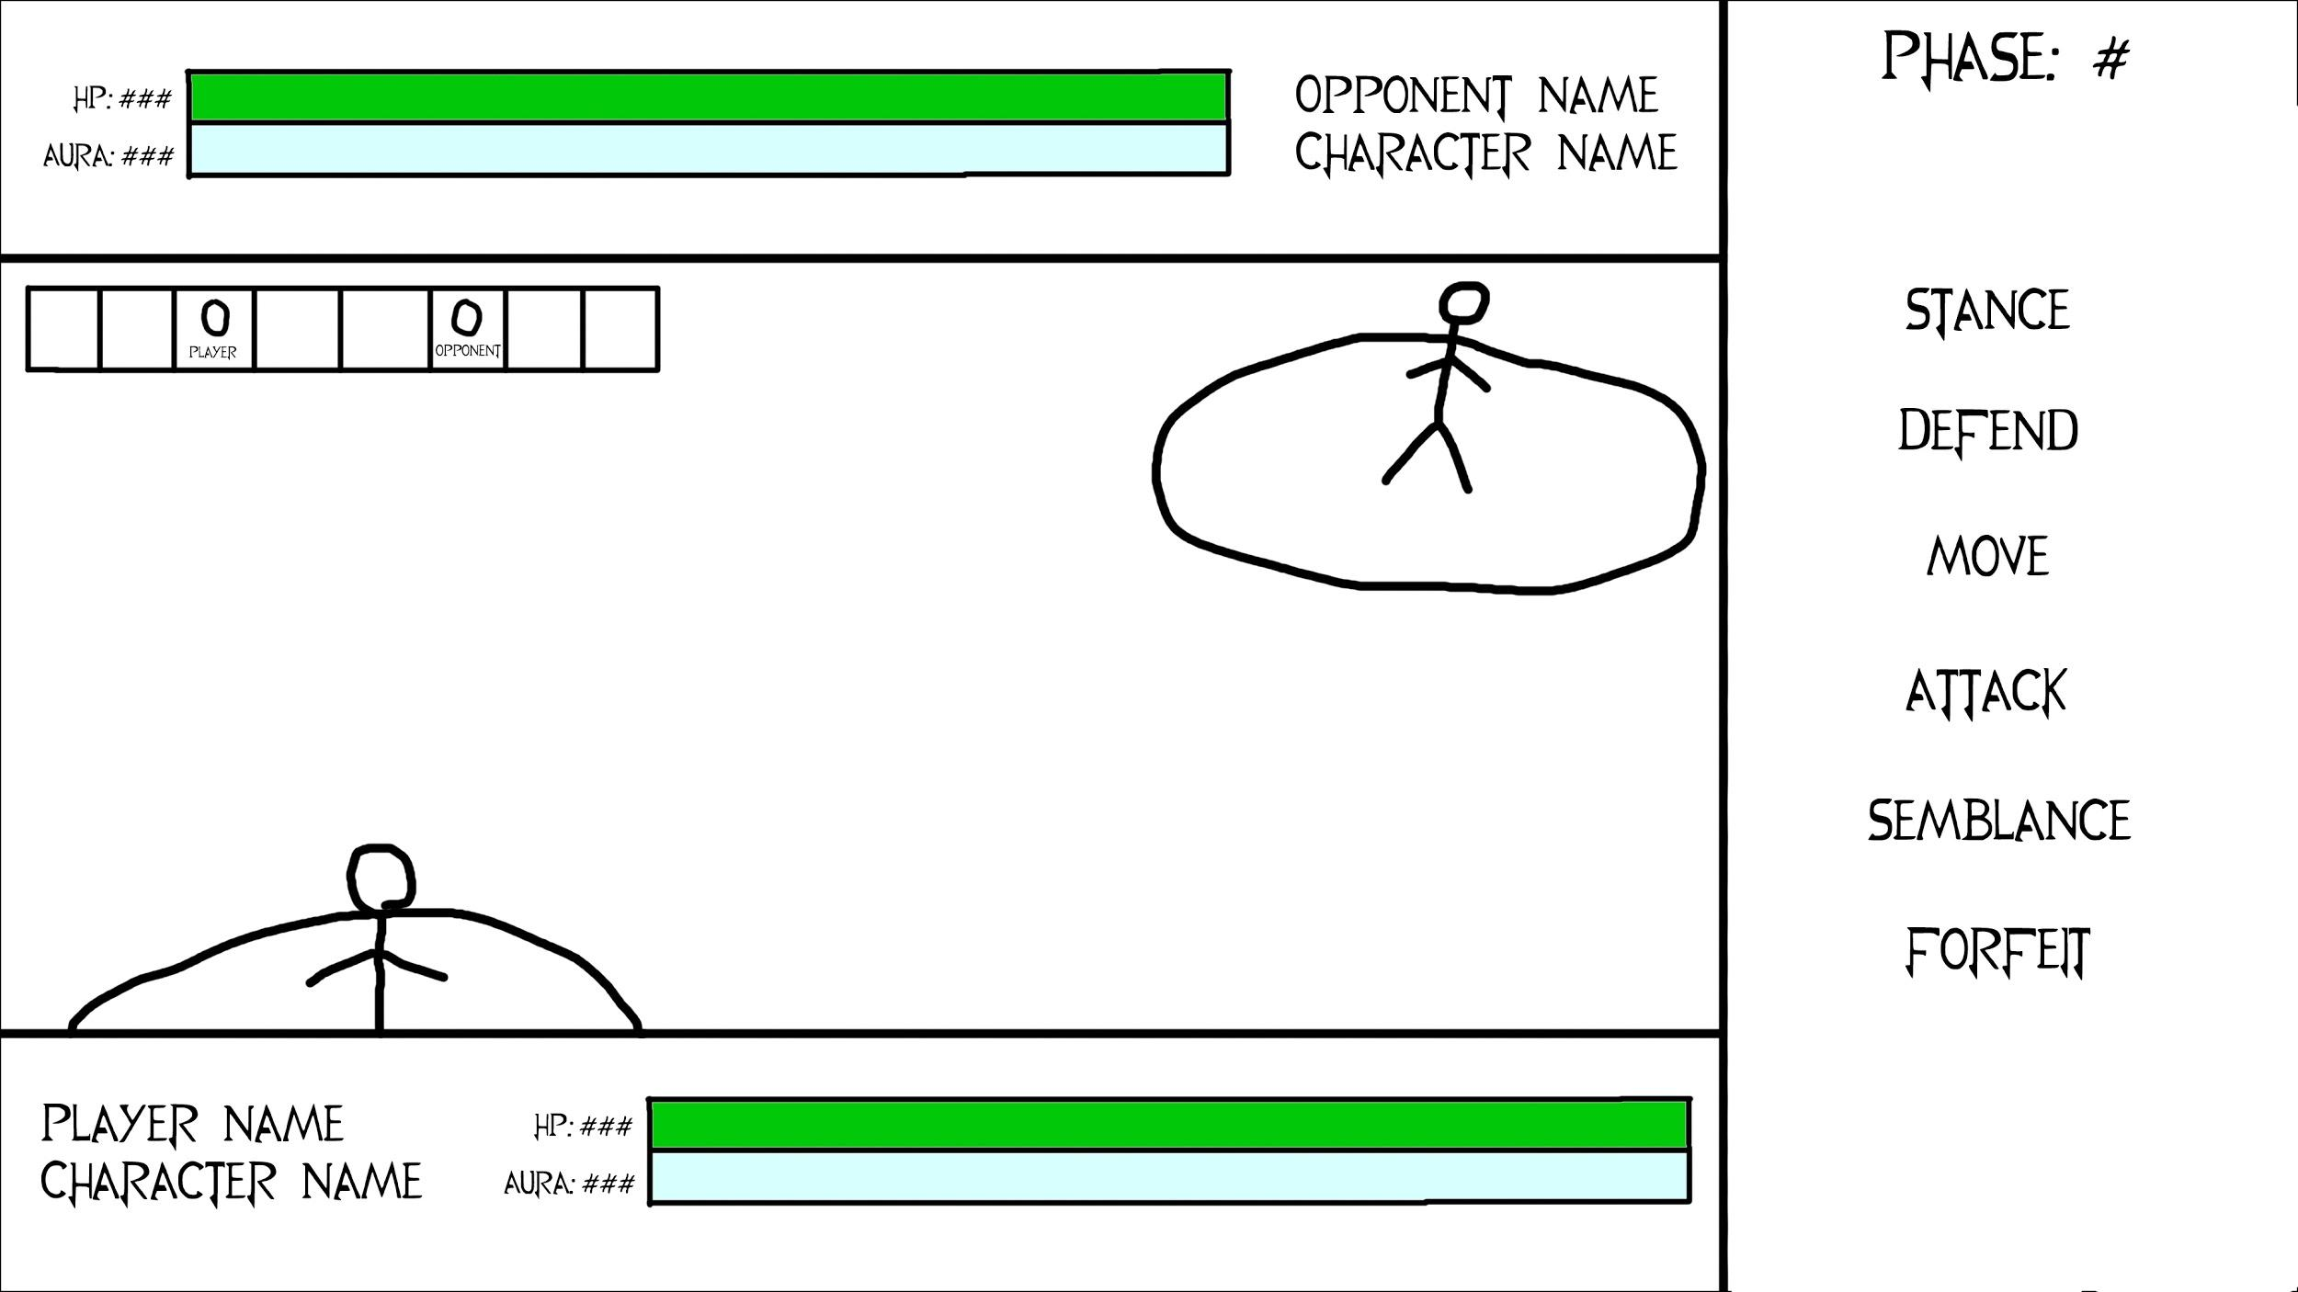**Battle:**